Adam and Eve
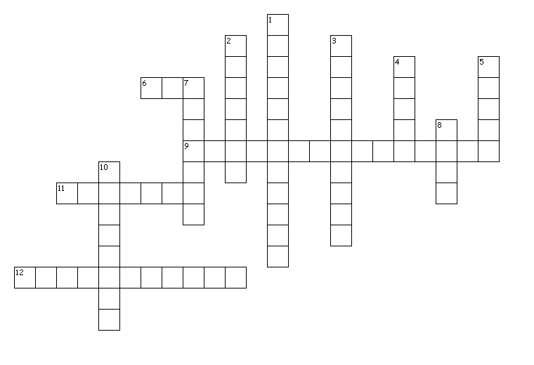

Across
6. taken from Adam to make Eve
9. where the fruit came from
11. Adam and Eve are considered our first
12. we inherited this from Adam and Eve

Down
1. where Adam and Eve lived
2. to do wrong
3. preserved from original sin
4. God sent to guard the Garden of Eden so no one could enter
5. told Eve to eat the fruit
7. takes away original sin
8. named the animals
10. ability to choose

Designed in Puzzlemaker from DiscoverySchool.com

Answers:

Across
6. taken from Adam to make Eve (rib)
9. where the fruit came from (Tree of Knowledge)
11. Adam and Eve are considered our first (parents)
12. we inherited this from Adam and Eve (original sin)

Down
1. where Adam and Eve lived (Garden of Eden)
2. to do wrong (disobey)
3. preserved from original sin (Virgin Mary)
4. God sent to guard the Garden of Eden so no one could enter (angel)
5. told Eve to eat the fruit (snake)
7. takes away original sin (baptism)
8. named the animals (Adam)
10. ability to choose (free will)

